Standard Operating Procedure

*Canceling or Deploying Deployments on OSE Console*

## PURPOSE

The purpose of this standard operating procedure (SOP) is to provide a detailed step-by-step procedure to cancel or deploy deployments on OSE Console. **In Prod environments, confirm that traffic is removed and SAM has approved before following this SOP.**

## PROCEDURE

1. Double check to be in the correct environment and the correct project (i.e. ram-dev1 in DevTest Black)
2. To cancel an ongoing deployment on the OSE console, click on “Overview” tab on the left of the page, which leads to the overview page. Click “Cancel” (in green rectangle):

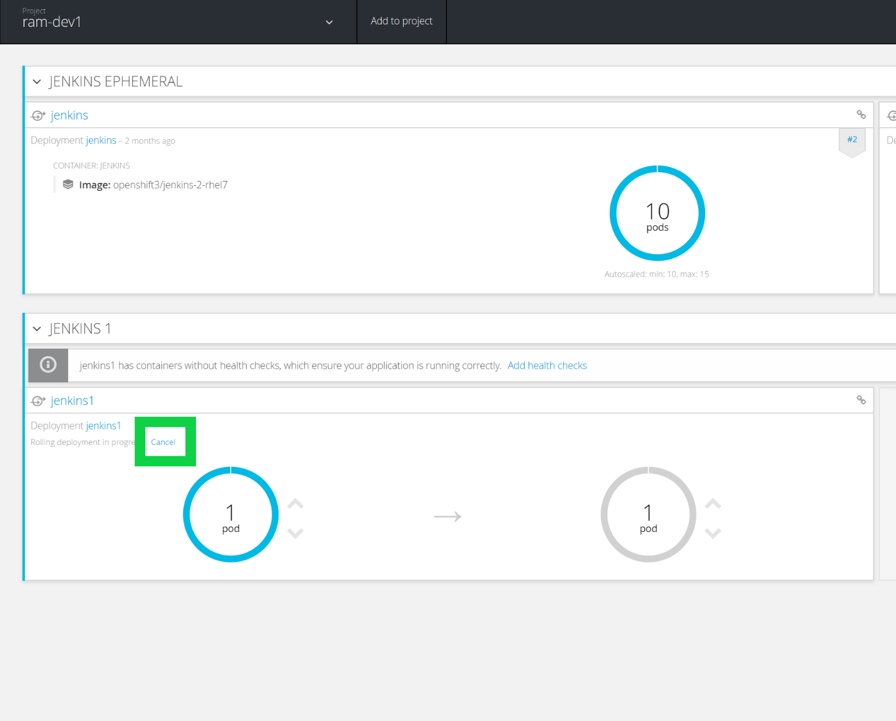

Then a box would pop up. Read it and click “Yes, cancel” button in red rectangle to cancel the ongoing deployment:

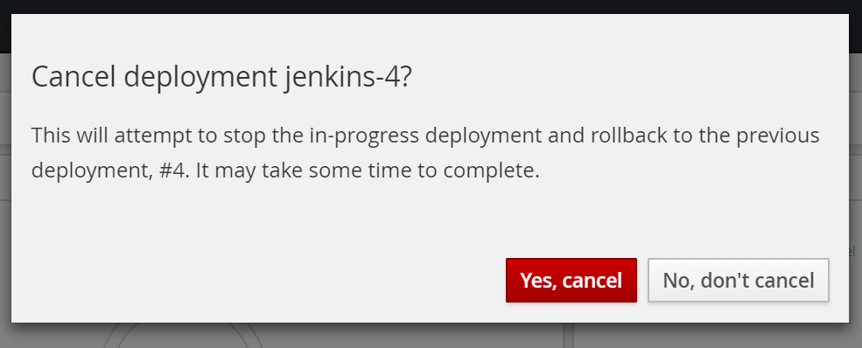

There should be a message at the top in a green box that says “Cancelling deployment…”: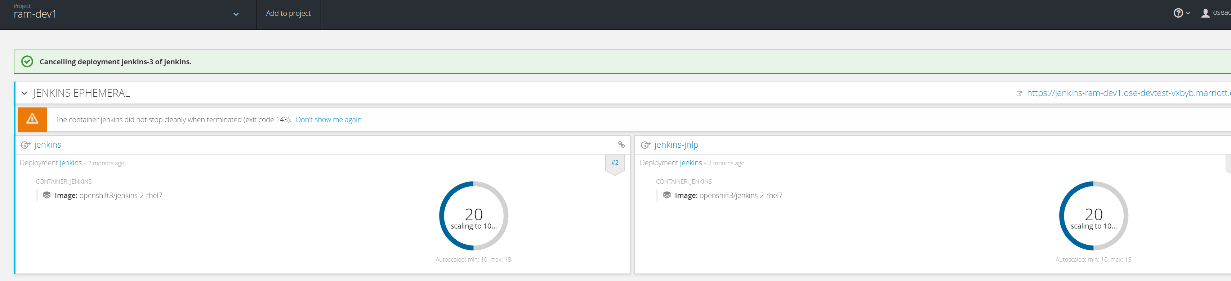

Verify that the deployment is indeed canceled.

1. To deploy a deployment on the OSE console, click on “Applications” tab on the left of the page then “Deployments”, which leads to list of deployments:

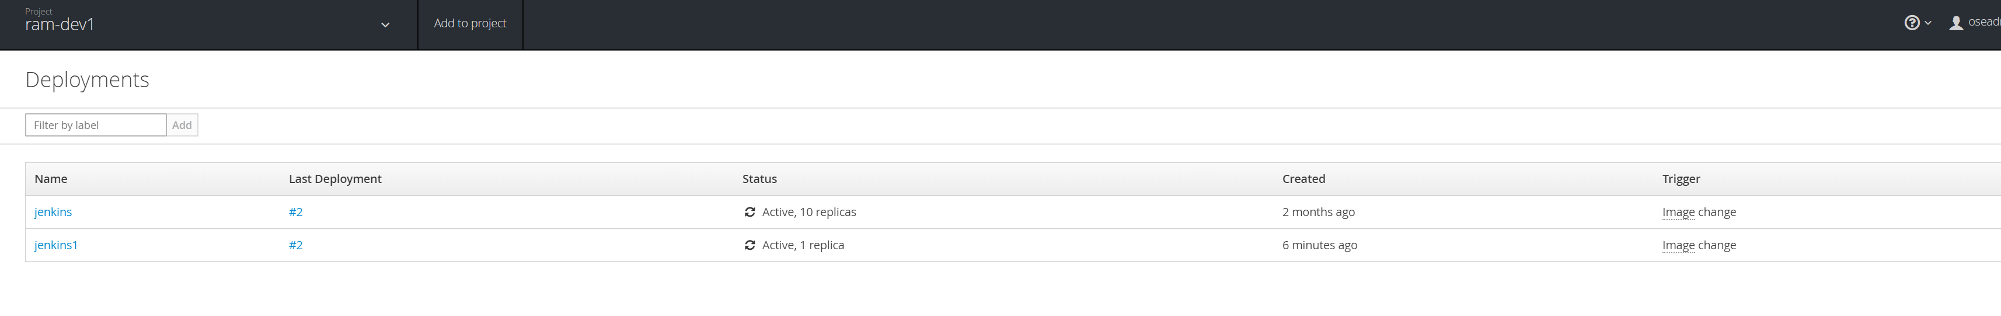

Look for the correct deployment and click on it. Then click “Deploy” (in green rectangle):

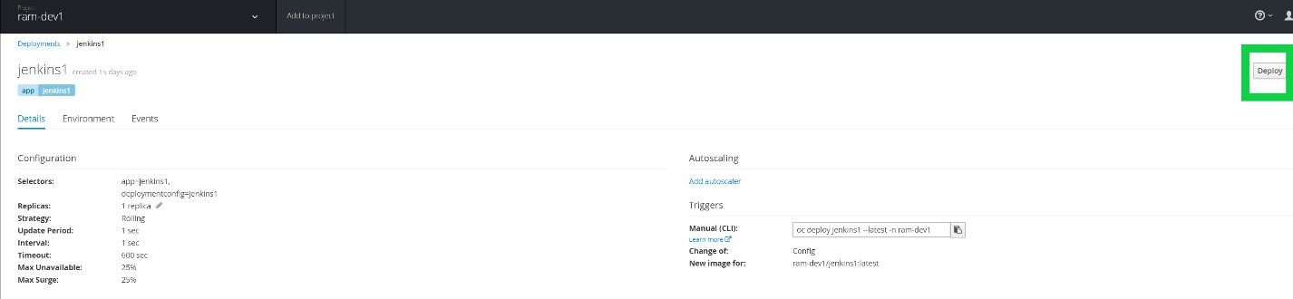

There should be a message at the top in a green box that says “Deployment … has started”:

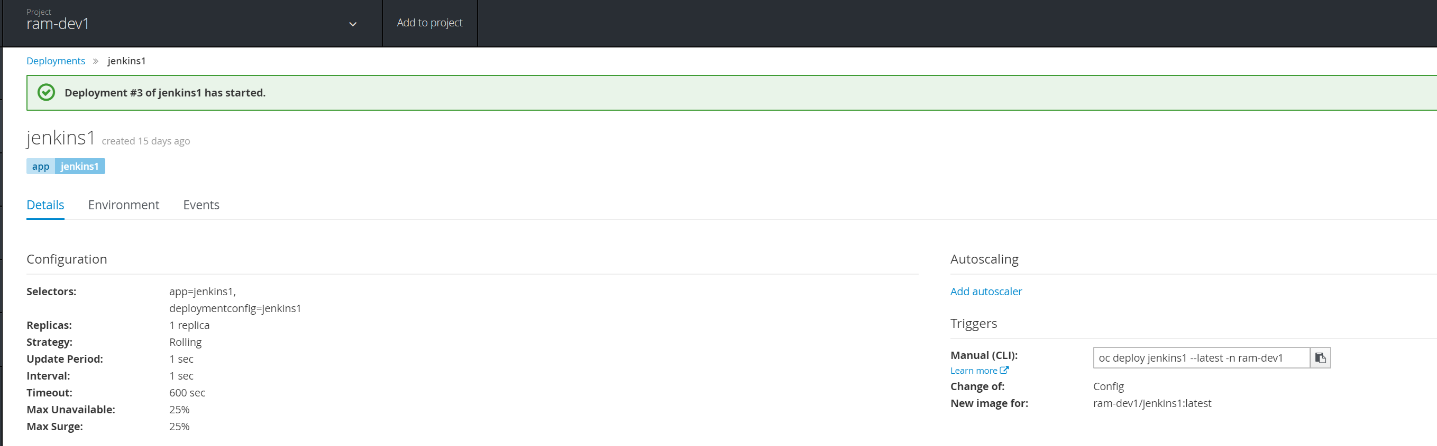

Verify that the deployment has been completed at the bottom of the same page:

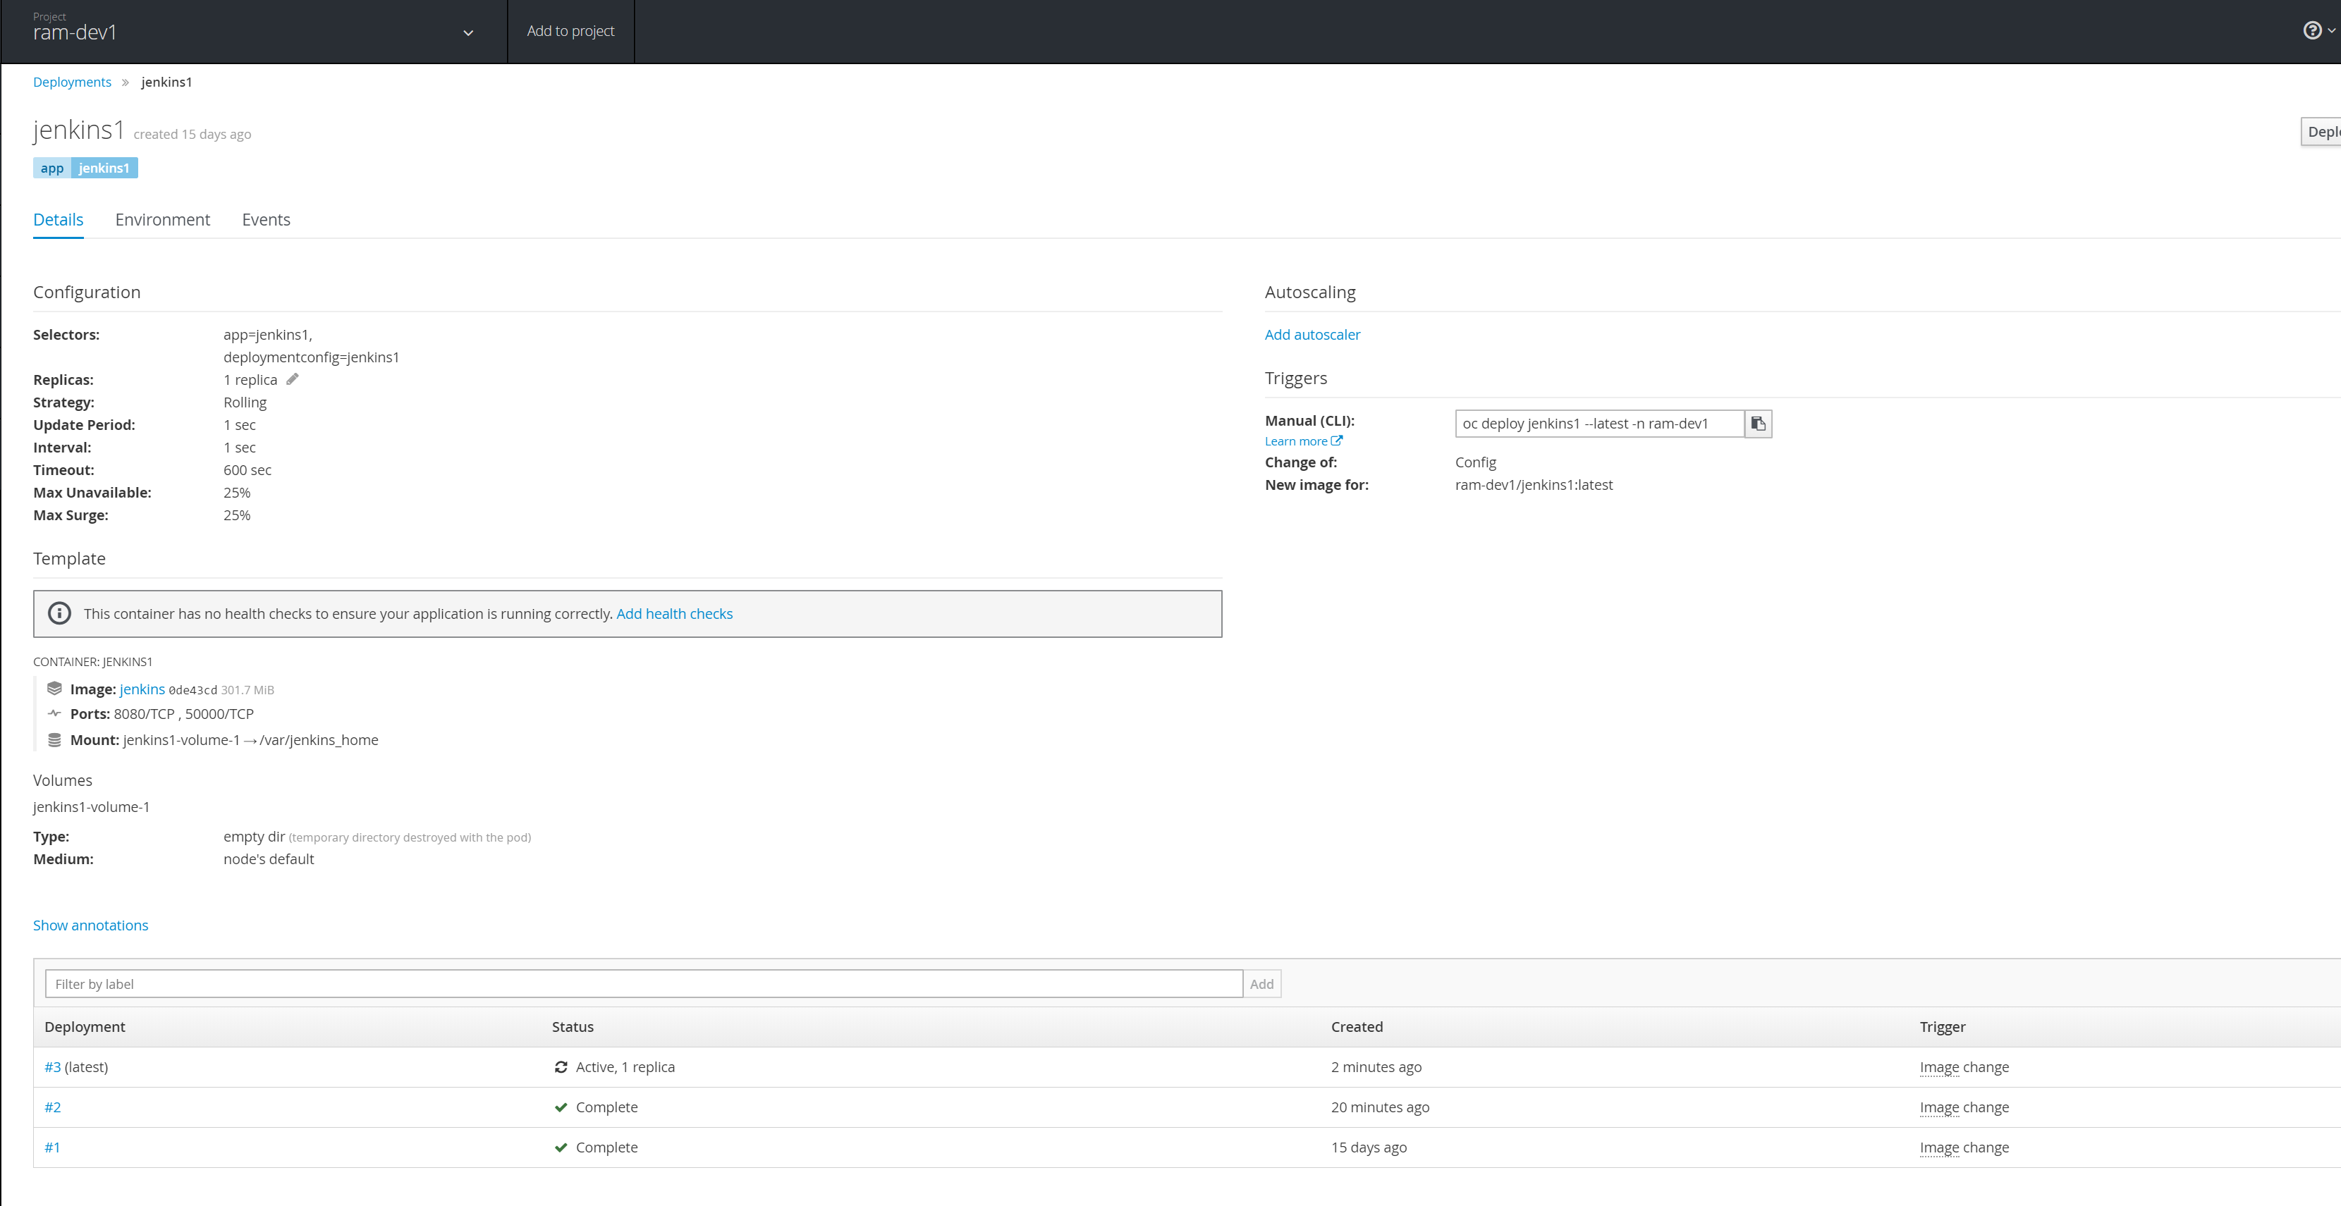

## VALIDATION

Follow the validation steps in “Procedure”.

**Document Version Control**

|  |  |  |  |
| --- | --- | --- | --- |
| Version | Effective Date | Reviewed by | Approved by |
| 1.0 | 1/24/2019 | KyungIn Kim | Yashi Kumar |
|  |  |  |  |

Document Modification History & Revision Log

|  |  |  |  |  |  |  |
| --- | --- | --- | --- | --- | --- | --- |
| Version | Date Modified | Revised by | Role | Section Affected | Reference | Remarks |
| 1.0 |  |  |  |  |  |  |
| 1.1 |  |  |  |  |  |  |